**DAILY ONLINE ACTIVITIES SUMMARY**

|  |  |  |  |  |  |  |  |  |
| --- | --- | --- | --- | --- | --- | --- | --- | --- |
| **Date:** | 18-06-2020 | | | | | **Name:** | D Richard Franklin | |
| **Sem & Sec** | Fourth sem section A | | | | | **USN:** | 4AL18CS020 | |
| **Online Test Summary** | | | | | | | | |
| **Subject** | | N/A | | | | | | |
| **Max. Marks** | | - | | **Score** | | | - | |
| **Certification Course Summary** | | | | | | | | |
| **Course** | 1. **Data science with python** | | | | | | | |
| **Certificate Provider** | | | greatlearning | | **Duration** | | | 3 hr |
| **Coding Challenges** | | | | | | | | |
| **Problem Statement:**  1: [Find the smallest positive integer value that cannot be represented as sum of any subset of a given array sorted in ascending order.](https://github.com/orgs/alvas-education-foundation/teams/2nd-year/discussions/124) | | | | | | | | |
| **Status:** completed | | | | | | | | |
| **Uploaded the report in Github** | | | | | yes | | | |
| **If yes Repository name** | | | | | <https://github.com/alvas-education-foundation/Richard_Franklin> | | | |
| **Uploaded the report in slack** | | | | | yes | | | |

**Online Test Details: N/A**

**Online Course Details:**

1. Name of course: **Data science with python**

Certificate provider: greatlearning

The total course was about how we can get thorough with data science and data manipulation with python. Here a lot of basic details regarding statistical representation of data is discussed, along with few important parameters regarding the same. How python can be used to do the analysis and how can we come forth with the solution. Few basic details of python is also discussed here.

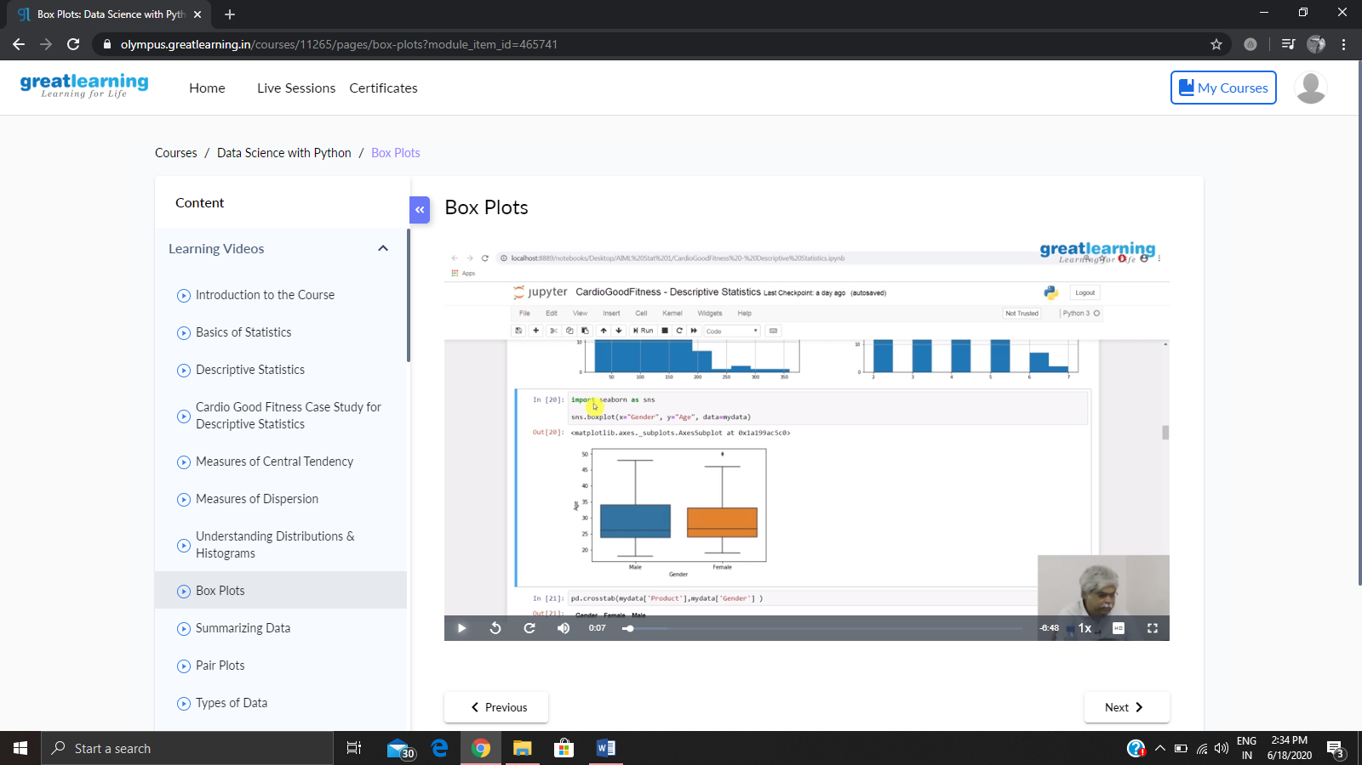

**Online coding:**

Problem 1: (using Python) [Find the smallest positive integer value that cannot be represented as sum of any subset of a given array sorted in ascending order.](https://github.com/orgs/alvas-education-foundation/teams/2nd-year/discussions/124)

